**Streams assignments** Setup:

**Create the following classes:**

**class Fruit { String name; int calories; int price; String color; }**

**class News { int newsId; String postedByUser; String commentByUser; String comment; }**

**class Trader { String name; String city; }**

**class Transaction { Trader trader; int year; int value; }**

1. Display the fruit names of low calories fruits i.e. calories < 100 sorted in descending order of calories.

2. Display color wise list of fruit names.

3. Display only RED color fruits sorted as per their price in ascending order.

4. Find out the newsId which has received maximum comments.

5. Find out how many times the word 'budget' arrived in user comments all news.

6. Find out which user has posted maximum comments.

7. Display commentByUser wise number of comments.

8. Find all transactions in the year 2011 and sort them by value (small to high).

9. What are all the unique cities where the traders work?

10. Find all traders from Pune and sort them by name.

11. Return a string of all traders’ names sorted alphabetically.

12. Are any traders based in Indore?

13. Print all transactions’ values from the traders living in Delhi.

14. What’s the highest value of all the transactions?

15. Find the transaction with the smallest value

Q1)Create the following classes:

class Fruit { String name; int calories; int price; String color; }

Display the following:

1. Display the fruit names of low calories fruits i.e. calories < 100 sorted in descending order of calories.

2. Display color wise list of fruit names.

3. Display only RED color fruits sorted as per their price in ascending order.

Code Specifications:

class Fruit {

private String name;

private int calories;

private int price;

private String color;

}

public class Assignment5Q1 {

public static List<String>reverseSort(ArrayList<Fruit> fruits) {}

public static ArrayList<Fruits> sort(ArrayList<Fruits> Fruits) {}

public static ArrayList<Fruit>filterRedSortPrice(ArrayList<Fruit>

public static void main(String[] args) {}

}

**Code**: - 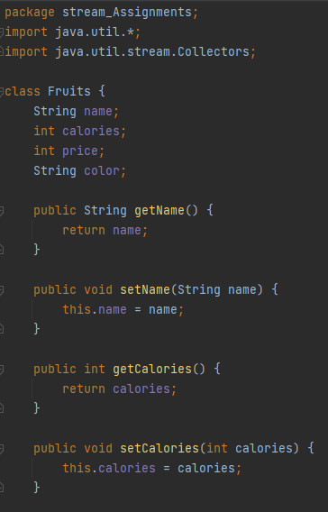

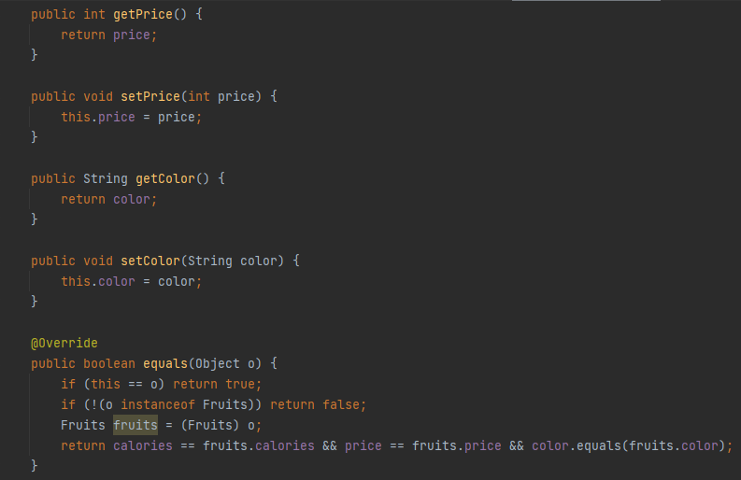

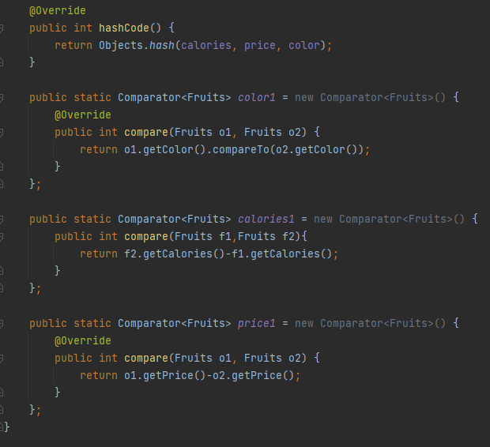

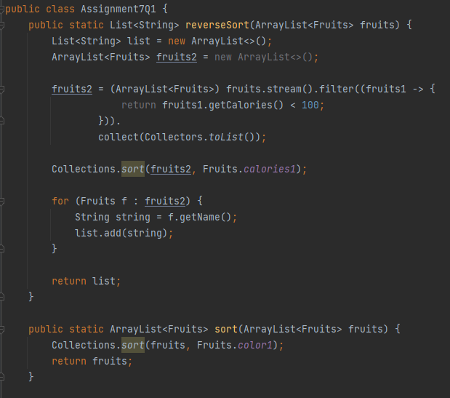

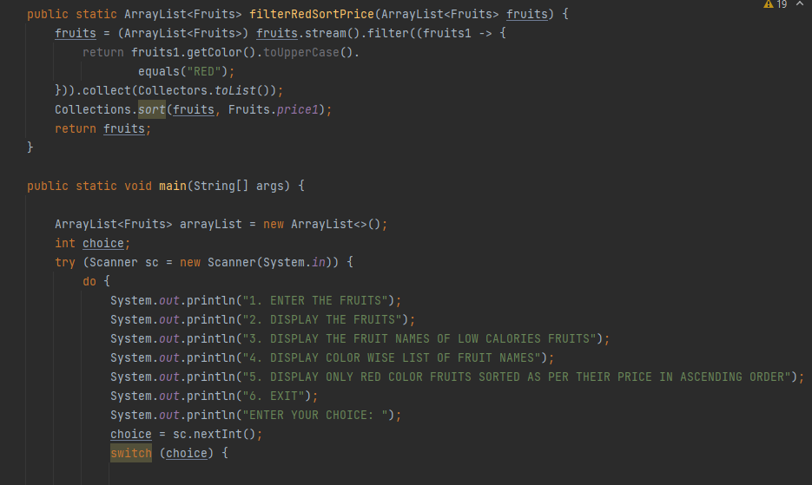

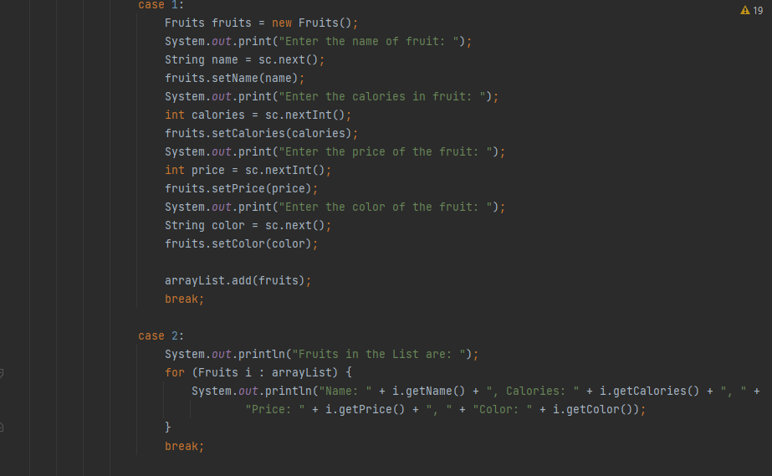

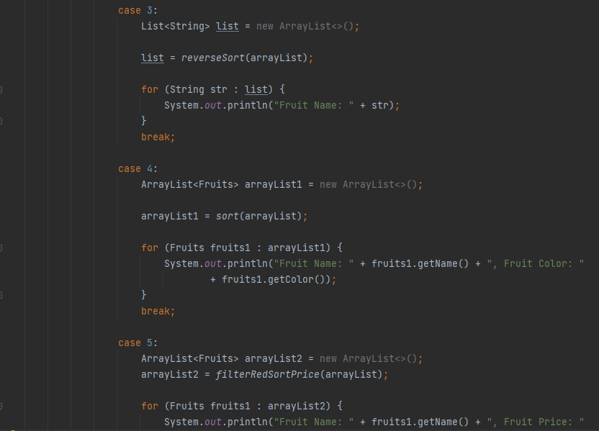

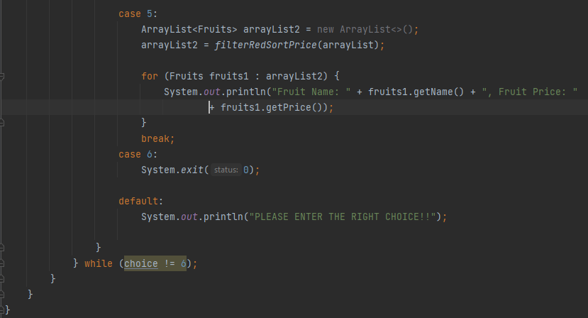

**output :-** 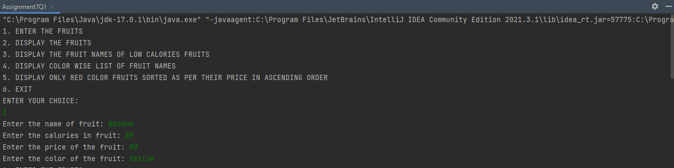

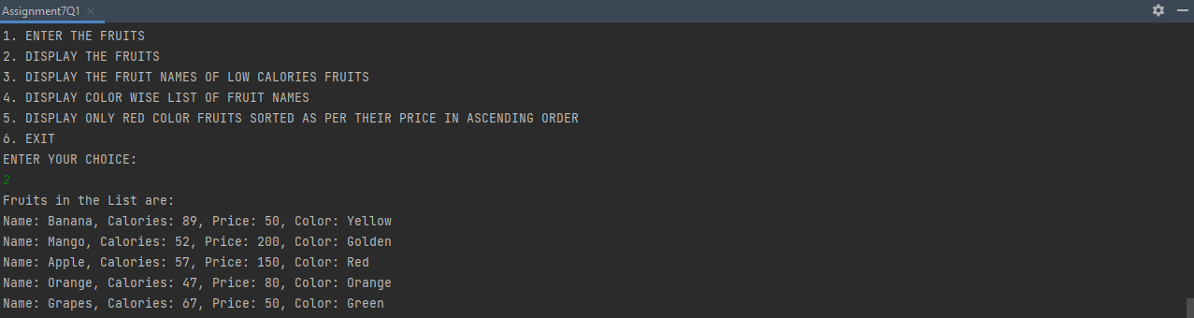

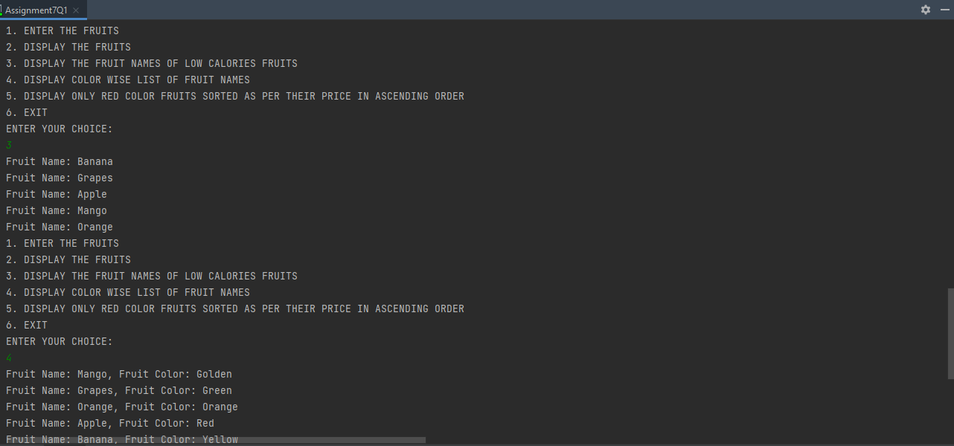

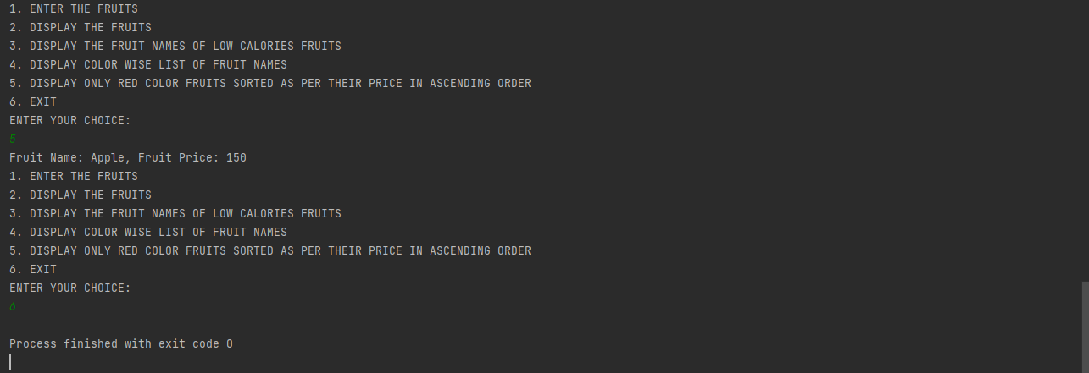

**Q2)**Setup:

Create the following classes:

class News { int newsId; String postedByUser; String commentByUser; String comment; }

Find Out:

1. Find out the newsId which has received maximum comments.

2. Find out how many times the word 'budget' arrived in user comments all news.

3. Find out which user has posted maximum comments.

4. Display commentByUser wise number of comments.

Code Specifications:

class News {

private int newsId;

private String postedByUser;

private String commentByUser;

private String comment;

}

public class Assignment5Q2 {

public static int maxComments(List<News> news) {}

public static int budgetCount (List < News > news) {}

public static String maxCommentsByUser (List < News > news) {}

public static Map<String, Integer>sortMaxCommentsByUser (List < News > news) {}

public static void main(String[] args) {}

}

**Code:-** 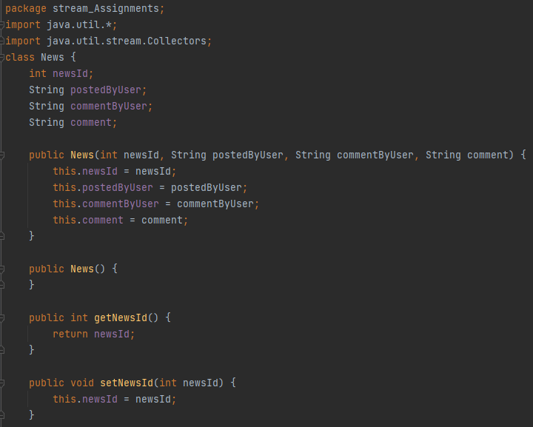

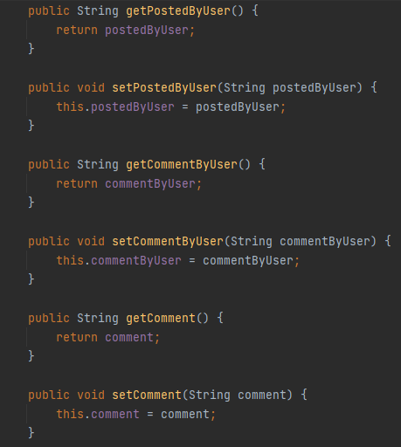

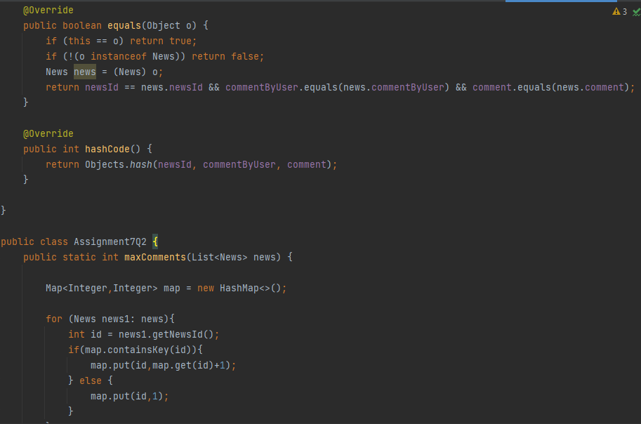

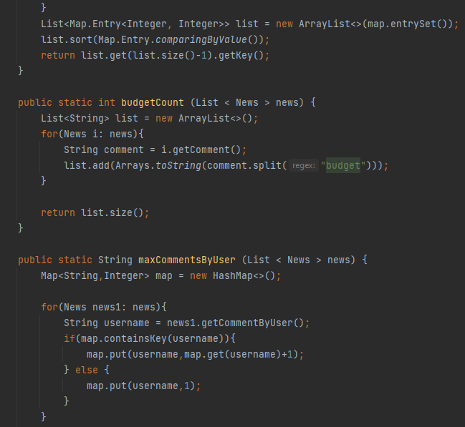

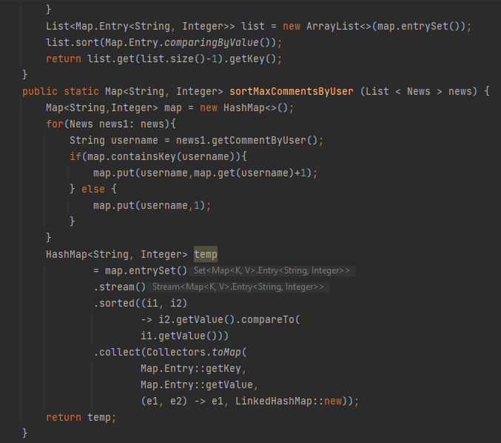

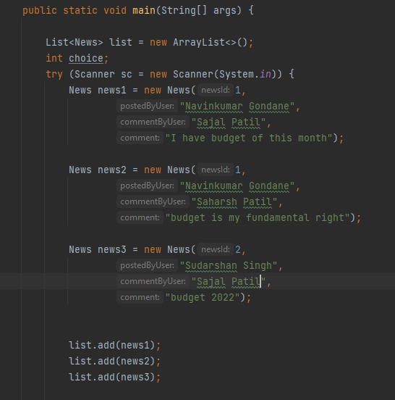

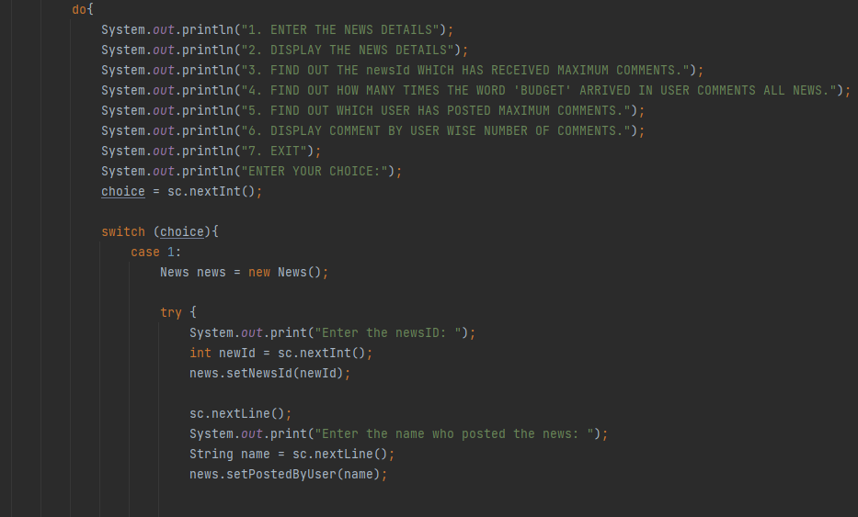

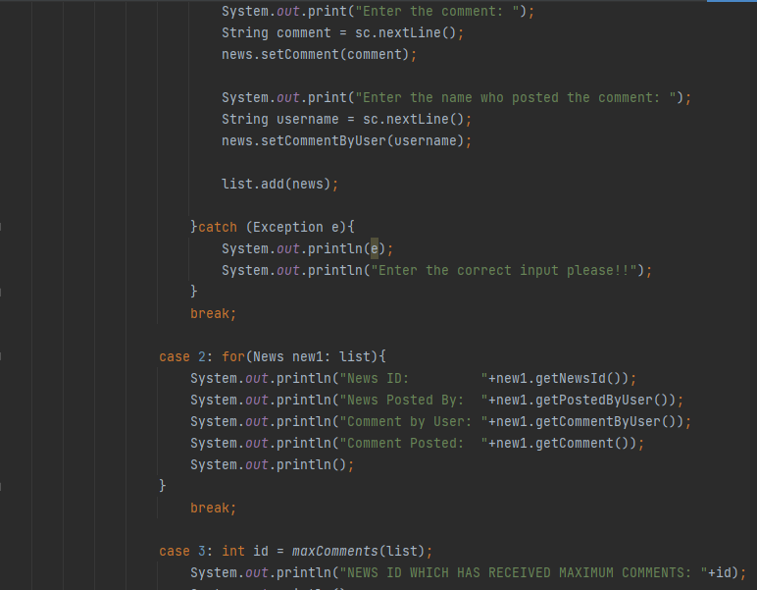

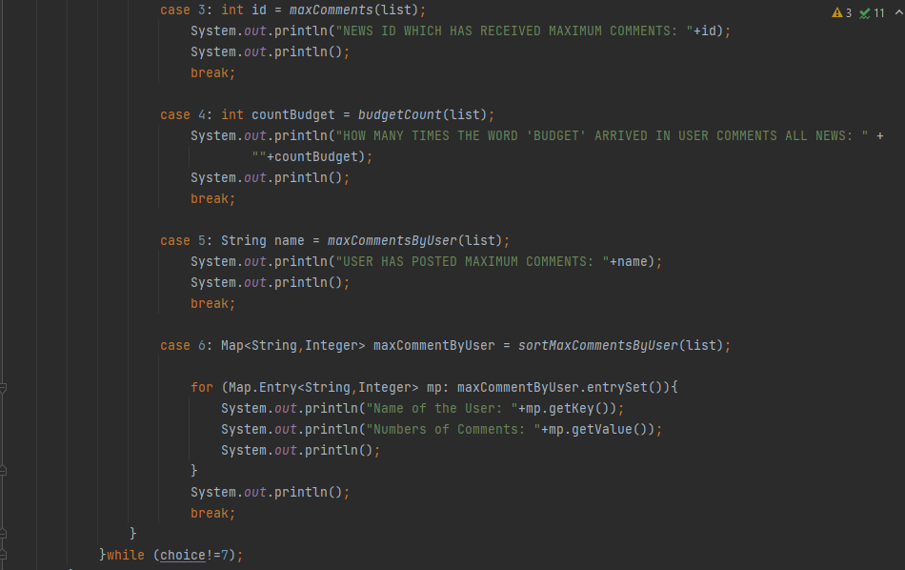

**Output :-** 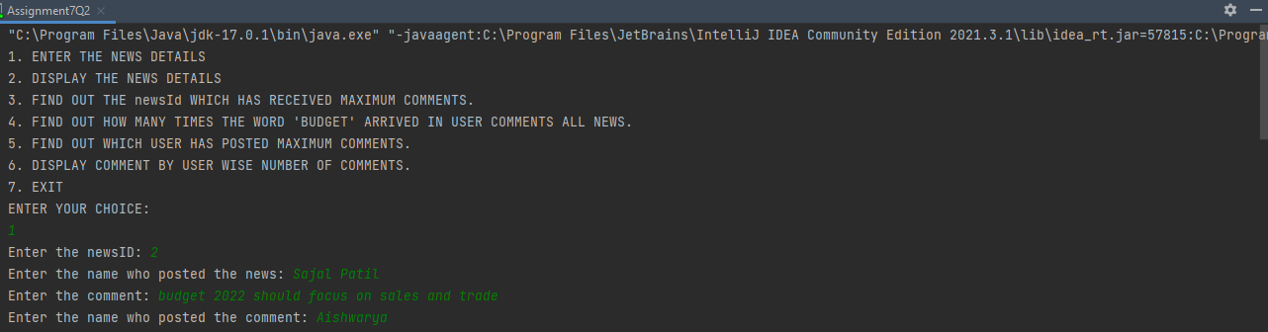

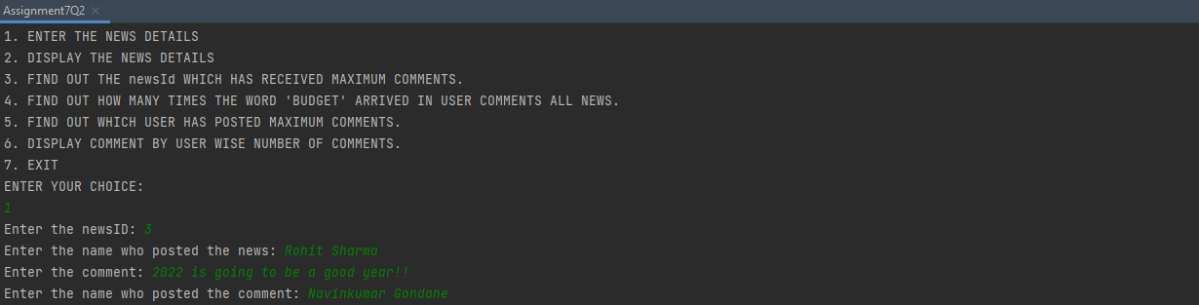

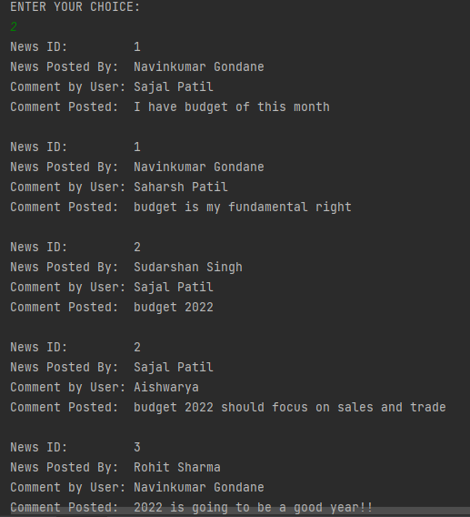

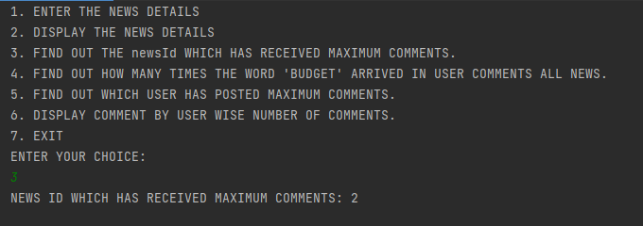

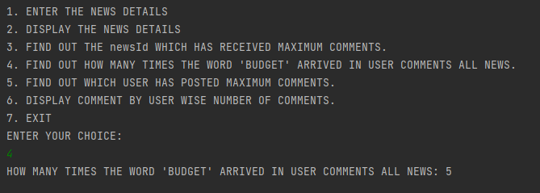

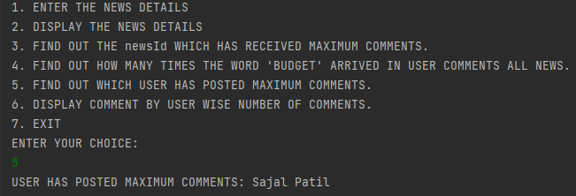

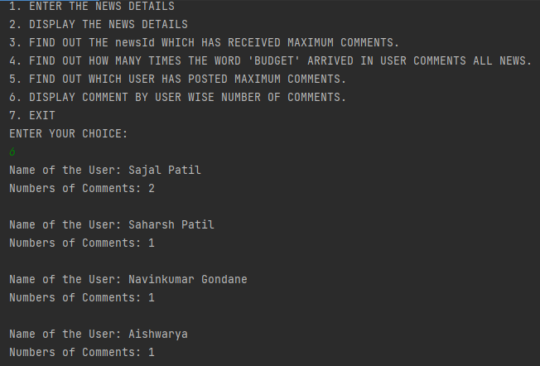

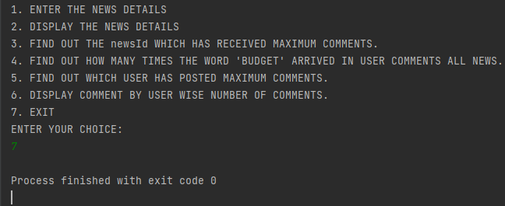

**Q3)Setup:**

Create the following classes:

class Trader { String name; String city; }

Find Out:

1. What are all the unique cities where the traders work?

2. Find all traders from Pune and sort them by name.

3. Return a string of all traders’ names sorted alphabetically.

4. Are any traders based in Indore?

Code Specifications:

class Trader {

private String name;

private String city;

}

public class Assignment5Q9 {

public static List<String>printUniqueCities (List <Trader> traders) { }

public static List<String>tradersFromPuneSortByName(List<Trader> traders) {}

public static String allTrader3Names(List<Trader> traders) {}

public static ArrayList<Trader>areAnyTradersFromIndore(ArrayList<Trader> traders) {}

public static void main(String[] args) {}

}

**Code:-** 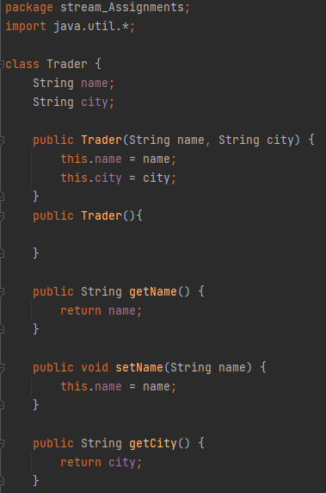

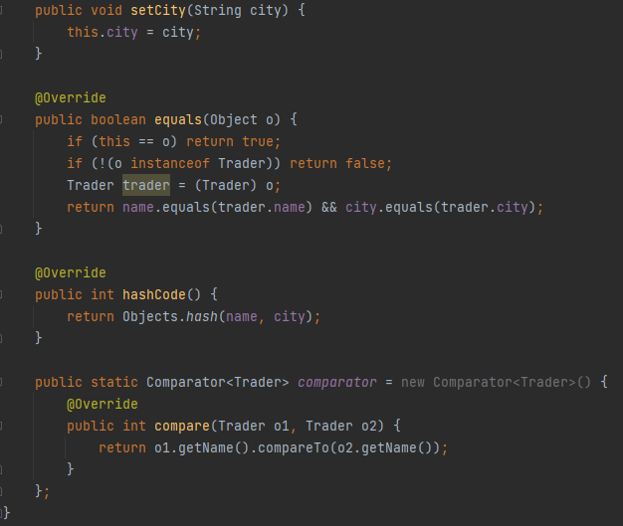

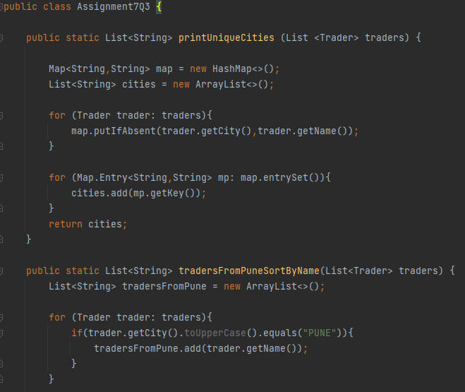

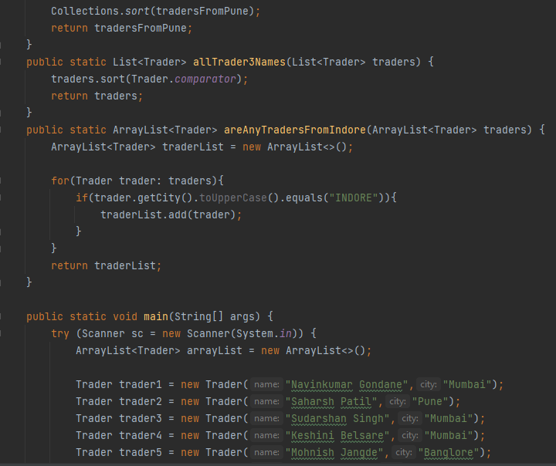

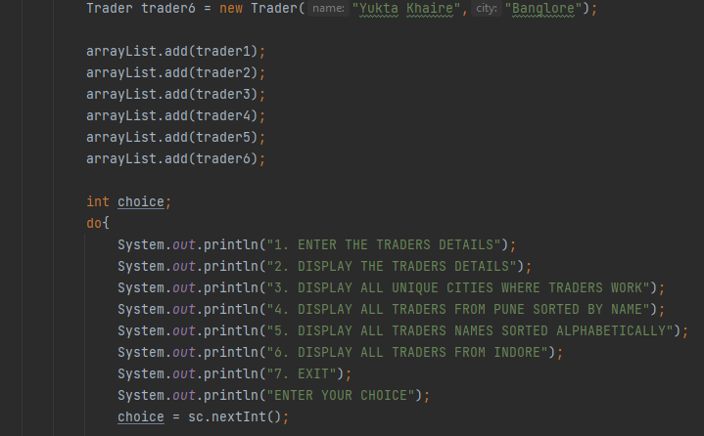

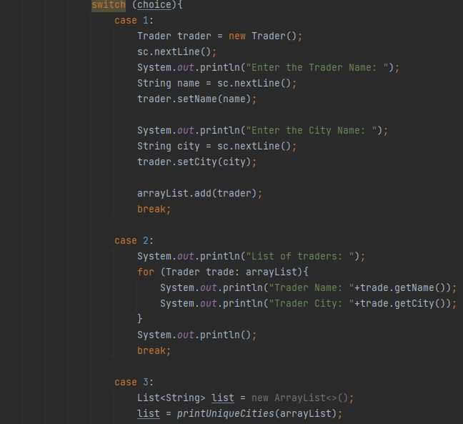

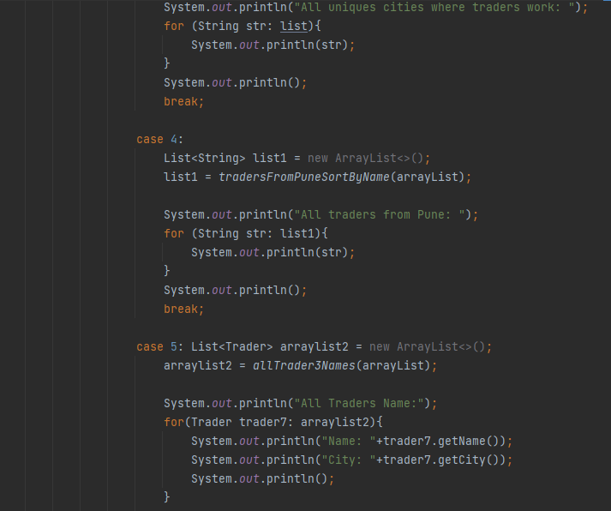

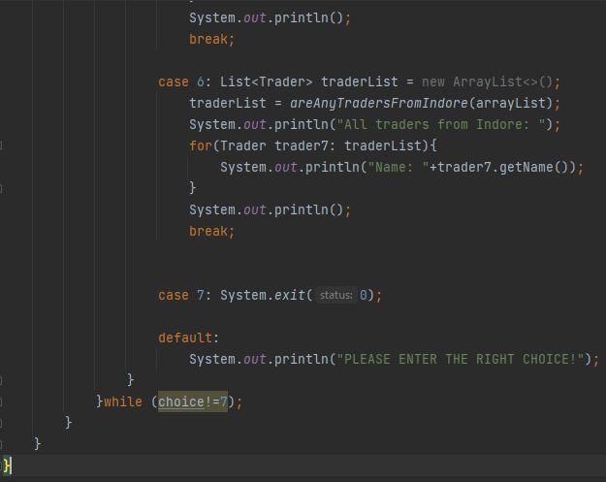

**Output :-** 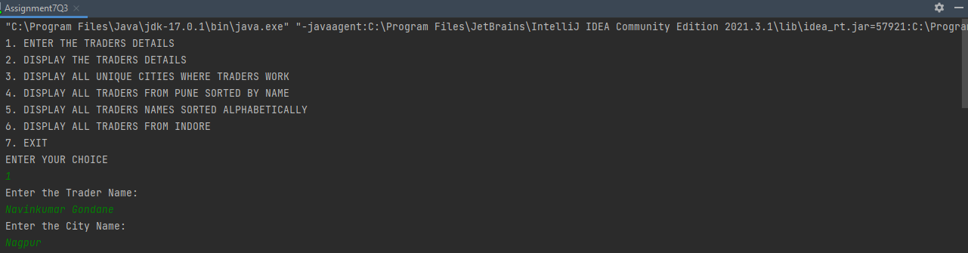

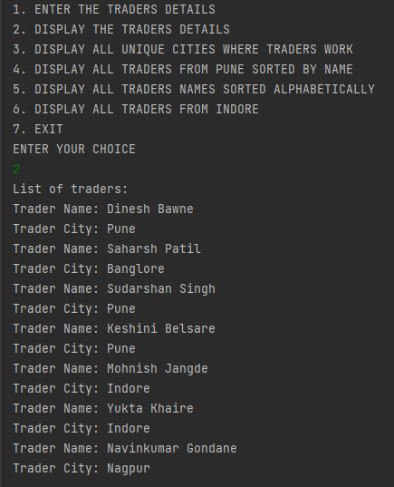

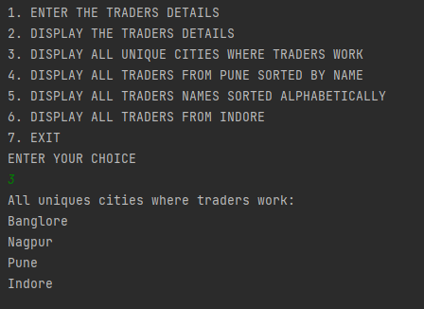

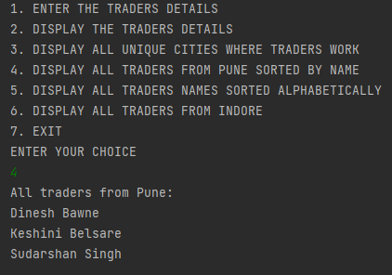

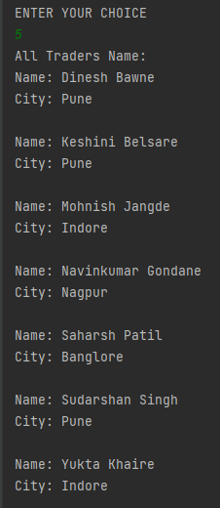

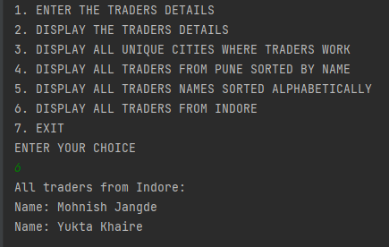

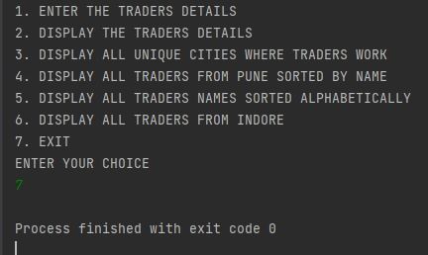

**Q4)Setup:**

Create the following classes:

class Trader { String name; String city; }

class Transaction { Tradertrader; int year; int value; }

1. Find all transactions in the year 2011 and sort them by value (small to high).

2. Print all transactions’ values from the traders living in Delhi.

3. What’s the highest value of all the transactions?

4. Find the transaction with the smallest value.

Code Specifications:

class Trader {

private String name;

private String city;

}

class Transaction {

private Trader trader;

private int year;

private int value;

}

public class Assignment5Q4 {

public static List<Transaction>sortTransactions(List <Transaction> transactions) {}

public static List<Integer>transactionsValuesDelhi(List<Transaction> transactions) {}

public static int highestTransaction(List<Transaction> transactions){}

public static int smallestTransaction(List<Transaction> transactions){}

public static void main(String[] args) {}

}

**Code:-** 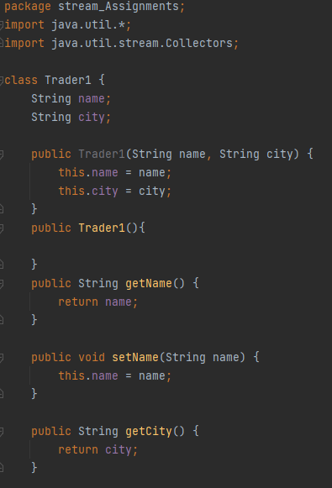

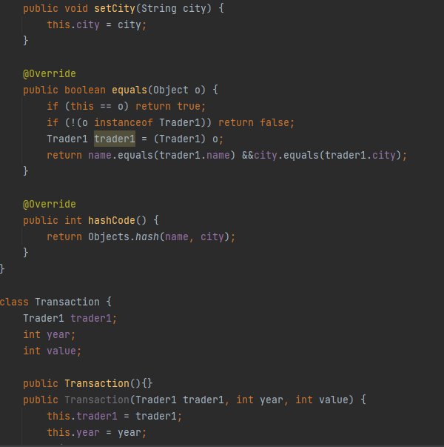

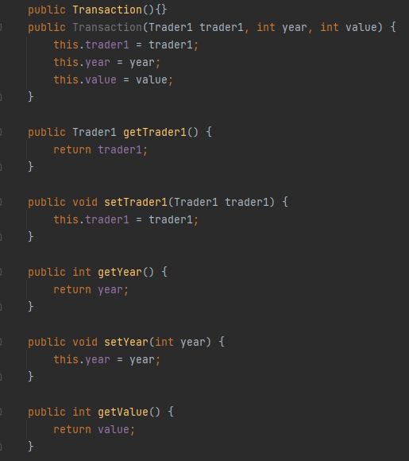

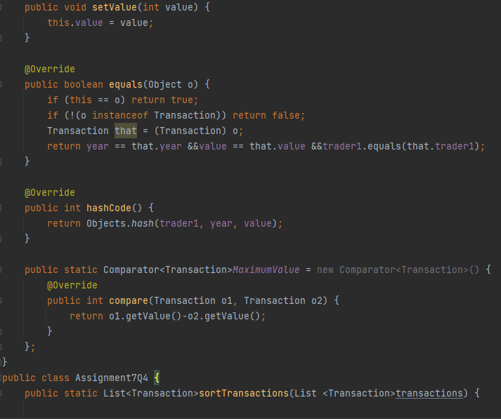

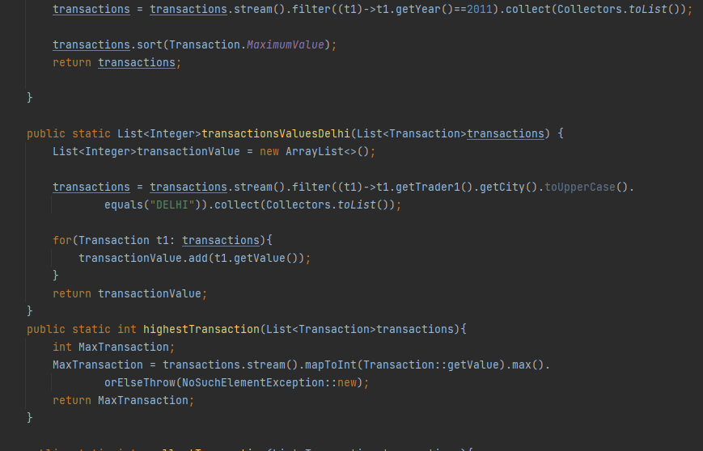

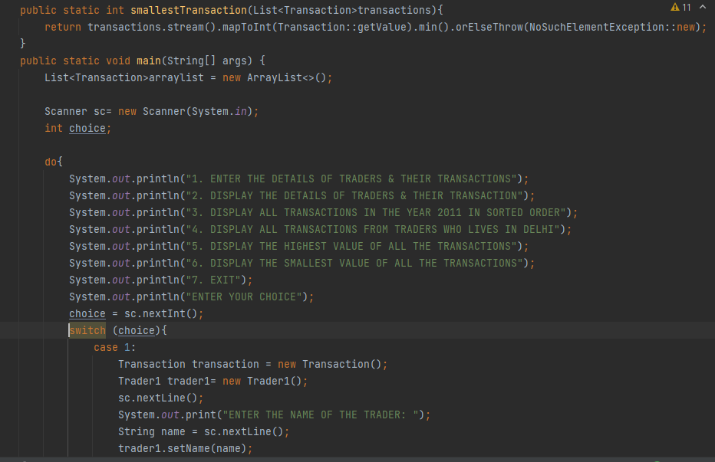

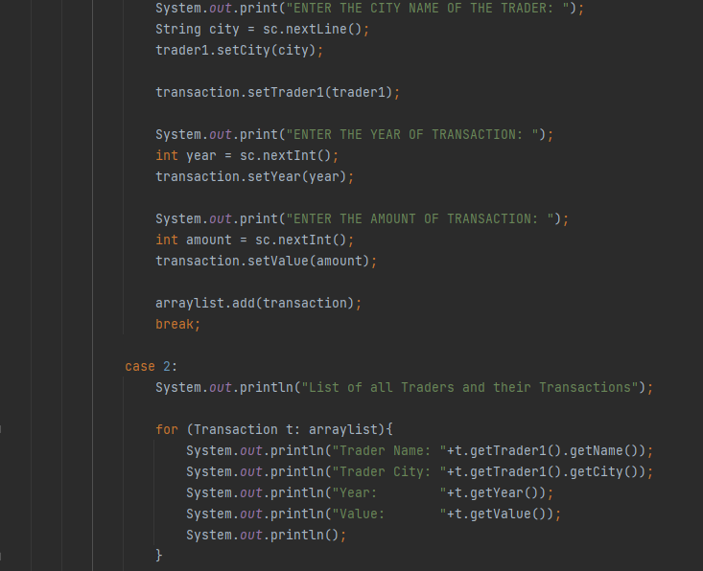

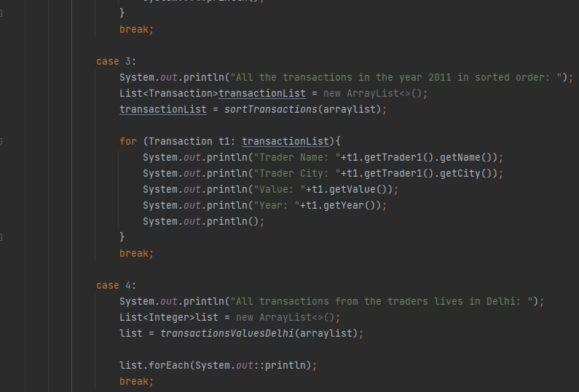

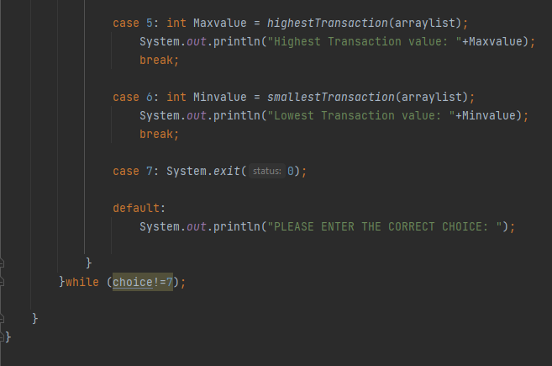

**Output:-** 